XIAN

See my bookmark for reasonable hotels.
www.travelchinaguide.com
Tourist buses are available on the railway station square – these are needed if going outside the city.

Xian, the eternal city, records the great changes of the Chinese nation just like a living history book. Called Chang'an in ancient times, Xian is one of the birthplaces of the ancient civilization in the Yellow River Basin area of the country. During Xian's 3,100 year development, 13 dynasties such as Zhou, Qin, Han and Tang placed their capitals here. So far, Xian enjoys equal fame with Athens, Cairo, and Rome as one of the four major ancient civilization capitals.
Xian is the capital of Shaanxi province, located in the southern part of the GuanZhong Plain. With the Qinling Mountains to the north and the Weihe River to the south, it is in a favorable geographical location surrounded by water and hills. It has a semi-moist monsoon climate and there is a clear distinction between the four seasons. Except the colder winter, any season is relatively suitable for traveling.
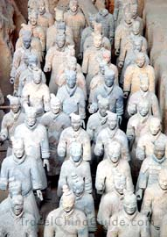
The cultural and historical significance of the area, as well as the abundant relics and sites, help Xian enjoy the laudatory title of "Natural History Museum".
The Museum of Terra Cotta Warriors and Horses is praised as "the eighth major miracle of the world". See Below.
Mausoleum of Emperor Qin Shi Huang is listed on the World Heritage List. However it is 22 miles from Xian, undeveloped, and probably not worth the trip.
City Wall of the Ming Dynasty is the largest and most intact Ming Dynasty castle in the world. See below
In the city, there is the 3000 year old Banpo Village Remains from the Neolithic Age. See Below.
and the Forest of Stone Steles that holds 3,000 stone steles of different periods from the Han Dynasty to the Qing Dynasty. See below
Around Xi'an, the Famen Temple enjoys the reputation of being the "forefather of pagodas and temples in Central Shaanxi," because it holds the finger bones of Sakyamuni--the founder of Buddhism. This sounds great, but unfortunately it is 75 miles from Xian. See be;pw
The natural landscape around Xian is also marvelous. Mt. Huashan, as one of the five best-known mountains in China, is famous for its breath-taking cliffs and its unique characteristics.
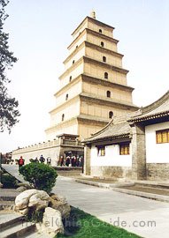
As tourist development grows in Xian, the hotel industry flourishes more and more. It is very easy to find a hotel in Xian, ranging from 5 star hotels to youth hostels. Of course, it will be any traveler's first choice to stay in the city center due to the superior geographical location and the convenient transportation.
Praised as "the capital of table delicacies", Xian has been rich in the delicious Shaanxi snack, delicate Guangdong Cuisine, various kinds of fashionable foreign delicacies, and popular Sichuan Cuisine such as the hot pot. Among all the delicacies, the most famous and popular one is the Muslim Snack Street.
Xian is the most important city in northwest China, and so there are a lot of shopping outlets for locals and tourists alike. There are many big shopping centers, department stores and supermarkets in and around Xian city - the biggest and most comprehensive being Kai Yuan Shopping Mall and Century Ginwa Shopping Mall.
The night life in Xian has a unique glamour. Traditional ways include enjoying the night scenery around the Bell Tower, taking part in a Tang Dynasty Dinner Show, strolling on the ancient Big Wild Goose Pagoda Square and watching the music fountain performance. More modern and fashionable ways include singing in the KTV, hanging out in a bar, or dancing in a Disco. All in all, any experience in this ancient city will bring you fun and possibly a little surprise!
CITY WALL
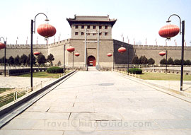

Recommended time – 3 hours
When Zhu Yuanzhang, the first Emperor of the Ming dynasty (1368-1644), captured Huizhou, a hermit named Zhu Sheng admonished him that he should "built high walls, store abundant food supplies and take time to be an Emperor," so that he could fortify the city and unify the other states. After the establishment of the Ming dynasty, Zhu Yuanzhang followed his advice and began to enlarge the wall built initially during the old Tang dynasty (618 -907), creating the modern Xian City Wall. It's the most complete city wall that has survived in China, as well being one of the largest ancient military defensive systems in the world.
After the extension, the wall now stands 12 meters (40 feet) tall, 12-14 meters (40-46 feet) wide at the top and 15-18 meters (50-60 feet) thick at the bottom. It covers 13.7 kilometers (8.5 miles) in length with a deep moat surrounding it. Every 120 meters, there is a rampart which extends out from the main wall. All together, there are 98 ramparts on the wall, which were built to defend against the enemy climbing up the wall. Each rampart has a sentry building, in which the soldiers could protect the entire wall without exposing themselves to the enemy. Besides, the distance between every two ramparts is just within the range of an arrow shot from either side, so that they could shoot the enemy, who wanted to attack the city, from the side. On the outer side of the city wall, there are 5948 crenellations, namely battlements. The soldiers can outlook and shoot at the enemy. On the inner side, parapets were built to protect the soldiers from falling off.
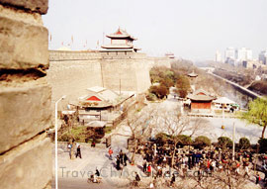
Since the ancient weapons did not have the power to break through a wall and the only way for an enemy to enter the city was by attacking the gate of the city wall. This is why complicated gate structures were built within the wall. In Xian, the city wall includes four gates and they are respectively named as Changle (meaning eternal joy) in the east, Anding (harmony peace) in the west, Yongning (eternal peace) in the south and Anyuan (forever harmony) in the north. The south gate, Yongning, is the most beautifully decorated one. It is very near to the Bell Tower, center of the city. Important greeting ceremonies organized by the Provincial Government are usually held in the south gate square.
Each city gate has three gate towers: Zhenglou, Jianlou and Zhalou. The most outside is Zhalou, which stands away from the City Wall and is opposite to Zhenglou. It was used to raise and lower the suspension bridge. Jianlou with small windows in the front and flanks was used as a defensive outpost. Zhenglou, in the inner, is the main entrance to the city. The wall connects Jianlou and Zhenglou Towers. The area between them within the wall was called "Wong Cheng", in which the soldiers stationed. From Wong Cheng, there are sloped horse passages leading to the top of the city wall.
Initially, the wall was built with layers of dirt, with the base layer including also lime and glutinous rice extract. Throughout the time Xian City Wall has been restored three times. In 1568, Zhang Zhi (the government officer of that period) was in charge to rebuild the wall with bricks. In 1781, another officer, Bi Yuan, refitted the city wall and the gate towers. More recently (since 1983) the Shaanxi Provincial Government restored the city wall again. A circular park has been built along the high wall and the deep moat. The thriving trees and flowers decorate the classical Chinese architecture of the wall, adding additional beauty to the city of Xian.
A nice suggestion for tourists: Try biking on the City Wall, you will have an enjoyable and interesting experience.
FOREST OF STONE STELES MUSEUM
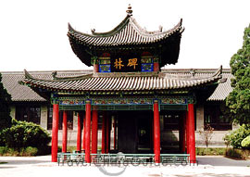
Bus Routes 14,402,239
Recommend time – 3 hours
Once the site of the Temple of Confucius during the Northern Song dynasty (960--1127), the Forest of Stone Steles Museum is situated on Sanxue Street, near the south gate of Xian City Wall. It was initially established in AD 1087 when some precious stone steles were moved here for safe keeping, including the "Classic on Filial Piety" written by Emperor Xuanzong in AD 745 and "the Kaicheng Stone Steles" arved in AD 837. With an area of 31,000 square meters, the Forest of Stone Steles used to be the principal museum for Shaanxi Province since 1944. Then because of the large number of stone steles, it was officially named as the Forest of Stone Steles Museum in 1992.
With 900 years of history, this treasure house holds a large collection of the earliest stone steles of different periods, from the Han Dynasty to the Qing Dynasty. All together, there are 3,000 steles and the museum is divided into seven exhibitions halls, which mainly display the works of calligraphy, painting and historical records. All of these record some achievements in the development of the Chinese culture and reflect the historical facts of the cultural exchanges between China and other countries.
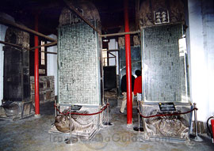
Now, please come with me to the exhibition halls.
Room One mainly displays "the Kaicheng Stone Classics", which contains twelve lections caved on 114 steles. The lections include "the Book of Changes", " the Book of History" , "the Book of Songs", "the Analects of Confucius" and some others of this kind. These are the must-read books for the intellectuals of the feudal society. At that time the printing was under development. In order to well preserve these lections, the rulers ordered to engrave them on the stone steles.

BANPO NEOLITHIC VILLAGE
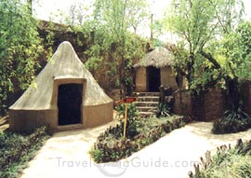
Bus Route 11, 105 Recommend time: 4 hours
The Banpo Museum is located in the eastern outskirt of Xian City, Shaanxi Province. As the first museum at the prehistoric site, it was built at the base of the excavations of the Banpo site. Since it opened to the public formally in 1958, two million people have visited it.
The Banpo Site is a typical Neolithic matriarchal community of the Yangshao Culture dating back about 6,000 years. At that time, the Banpo people used tools made primarily of wood and stone. Women, the crucial labor force, were responsible for making pottery, spinning, and raising the family, while men fished.
The approximately 4,500 square meters (about 1 acre) exhibit area of Banpo Museum is divided into two Exhibition Halls and a Site Hall.
The first Exhibition Hall is about the unearthed relic exhibitions consisting of the First Hall and the Second Hall. The showpieces in this two halls are primarily production tools and domestic tools used by the primitive Banpo people, including axes, chisels, sickles, and stone and pottery knives from which we can have a general picture of the production activities of the Banpo people thousands of years ago. In addition, artwork and adornments here reflect the social life, culture, art and inventions of the period.
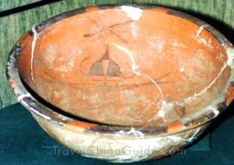
The second Exhibition Hall is primarily used for auxiliary exhibitions and it contains two halls. Special shows are held here on ethnology, folklore and the history of art related to the prehistoric culture.
The Site Hall is about 3,000 square meters (about 0.7 acre) and contains residential, pottery making and burial section. And among the three, the residential section is the main part of the site, including the huts, kilns and tombs of the primitive residents. All these present us an outlook of the aboriginal village and the hard situations of the forefathers in pursuing the civilization, reflecting the production level and the social systems at that period of time.
The Banpo Matriarchal Clan Community Village is an extension of the museum based on archeological findings. The entire village enriches the cultural connotation of the museum and carries forward the long and splendid history of China at the same time.

Terra Cotta Warriors and Horses
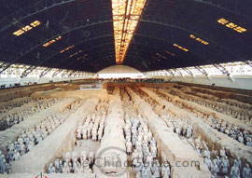

Bus Route 306,307
The Terra Cotta Warriors and Horses are the most significant archeological excavations of the 20th century. Work is ongoing at this site, which is around 1.5 kilometers east of Emperor Qin Shi Huang's Mausoleum, Lintong County, Shaanxi province. It is a sight not to be missed by any visitor to China.
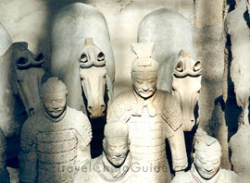
Upon ascending the throne at the age of 13 (in 246 BC), Qin Shi Huang, later the first Emperor of all China, had work begun on his mausoleum. It took 11 years to finish. It is speculated that many buried treasures and sacrificial objects had accompanied the emperor in his after life. A group of peasants uncovered some pottery while digging for a well nearby the royal tomb in 1974. It caught the attention of archeologists immediately. They came to Xian in droves to study and to extend the digs. They had established beyond doubt that these artifacts were associated with the Qin Dynasty (211 --206 BC).
The State Council authorized to build a museum on site in 1975. When completed, people from far and near came to visit. Xian and the Museum of Qin Terra Cotta Warriors and Horses have become landmarks on all travelers' tinerary.
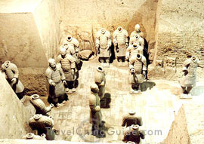
Life size terracotta figures of warriors and horses arranged in battle formations are the star features at the museum. They are replicas of what the imperial guard should look like in those days of pomp and vigor.
The museum covers an area of 16,300 square meters, divided into three sections: No. 1 Pit, No. 2 Pit, and No. 3 Pit respectively. They were tagged in the order of their discoveries. No. 1 Pit is the largest, first opened to the public on China's National Day, 1979. There are columns of soldiers at the front, followed by war chariots at the back.
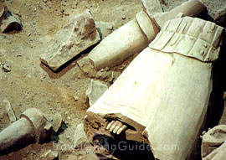
No. 2 Pit, found in 1976, is 20 meters northeast of No. 1 Pit. It contained over a thousand warriors and 90 chariots of wood. It was unveiled to the public in 1994.Archeologists came upon No. 3 Pit also in 1976, 25 meters northwest of No. 1 Pit. It looked like to be the command center of the armed forces. It went on display in 1989, with 68 warriors, a war chariot and four horses.
Altogether over 7,000 pottery soldiers, horses, chariots, and even weapons have been unearthed from these pits. Most of them have been restored to their former grandeur.
The Terracotta Warriors and Horses is a sensational archeological find of all times. It has put Xian on the map for tourists. It was listed by UNESCO in 1987 as one of the world cultural heritages.

Famen Temple

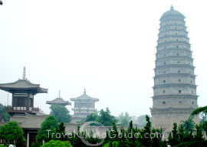
75 miles from the city. Take the tourist bus which is to Fufeng County at the Pan Village Bus Station located in the Yuxing Gate
In China, many temples house treasures and artifacts, but the sheer quantity and quality of treasures in the Famen Temple is rare. Situated in Famen Town of Fufeng County, about 120 kilometers (about 74.57 miles) west of Xian, Famen Temple is renowned for storing the veritable four slivers of the finger bone of the Sakyamuni Buddha.
Famen Temple was established in the Eastern Han Dynasty (25--220), for carrying forward Buddhism. The most representative structures in the temple are the Famen Temple Pagoda and Famen Temple Museum.
At the center of the temple is the 13-tiered octagonal pagoda under which it is said, a sliver of the finger bone of Sakyamuni buried. In 1981, subsidence of the pagoda led to reconstruction, during which, an Underground Palace was discovered unexpectedly in 1987. Many royal treasures and jewellery were found here-more than 2,000 pieces surrounded the Tang mandala (geometric designs, usually circular, symbolizing the universe). The most precious are the four slivers of veritable finger bone of the Sakymuni Buddha. At present, this is the biggest Buddhist underground palace so far discovered. From the grand architectural style, it is said to have been established in the Tang Dynasty (618-907). But why, and how such precious treasures were stored under the pagoda. Tracing back to a most flourishing time in Chinese history, formerly, Famen Temple was the royal temple during the Sui Dynasty (581-618) and Tang Dynasty. Emperors in Sui and Tang believed that enshrining and worshiping the bone of Sakyamuni would bring riches and peace to the land and its people. So an offering of treasure to the finger bone was made, it was housed in the Underground Palace.
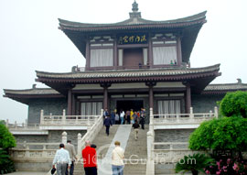
Due to the appropriate collection and further expounding of the cultural connotations of the treasures to the public, the Famen Temple Museum was established in 1987, which includes most of the precious treasures from the Tang Dynasty removed from Underground Palace, including gold and silverware, colored glaze ware, porcelain and silks. Owing to more and more tourists and their curiosity to the relics, two new exhibition halls were established in 2000. The exhibition area expanded from 500 square meters to 3,000 square meters, which well caters for the interest of tourists.
Nowadays, this, the most famous Buddhist temple, Famen Temple, plays a sovereign role in Chinese religion, and appeals to tourists from all over the world.

