We can look at the invoice on their website by using my email address and passwd: sequcbkt
dickYYXX
new price 10614 which includes travel insurance

Gate 1 Travel to Australia and NZ

Maria Zaccagni
mzaccagni@gate1travel.com
Gate 1 Travel
1-800-682-3333 Ext. 1130

Email: dick@dicksandy.org
Conf. # 217385

The quoted price/person was $5759 which includes air from LA. Because air flights cannot be booked yet, that is their best guess. They hope to know the final price in about a month.

From the per person price, subtract $800 because of a limited time special. That yields
$4959.

The land only price was $3719 - $800 = $2919.

We have put $100 *2 as a deposit on the UA Visa. That is nonrefundable – but we could probably get it back if the per person price turns out to be much more than $4959.

The rest of the money is due Nov. 16. At that time we can get trip insurance. As of now that would be $139/person. If the trip cost goes over $6000 then the trip insurance would be $279.

We can look at the invoice on their website by using my email address and passwd: sequcbkt

Contact | DANIELS, RICHARD | Passengers | 2 Adults
  Contact
  Name | DANIELS, RICHARD
  ContactID | 192364
  Email | dick@dicksandy.org
  Phone | 603-986-1585
  Fax
  Address | 479 CHASE RD  N SANDWICH, NH 03259-3614  US
  1. | DANIELS, RICHARD | Adult
  2. | COLE, SANDRA | Adult
Final Payment Date | 16 Nov 2008 | Deposit Date | 15 Jan 2008 | Total Received | 200.00
Departure Date | 31 Dec 2008 | Document Status |  | Total Due | 9,002.58
Created | 15 Jan 2008 / mbandeira | Lead Passenger | DANIELS, RICHARD | Brand/Market | GATE1 / SPA-ESC
  User
  Name | Maria da Conceicao Bandeira
  Email | mbandeira@gate1travel.com
  Extension | 1251
  Department | Res
- Australia: Passport and visa required. For more information on passports and visas, please see http://www.gate1travel.com/visas.htm.

- Services
QuantityDurationPriceTotal Date
Wed, 31 Dec 2008Description | 22 Day Australia & New Zealand  Based on Two Adults Sharing Room |  |  | 2 |  | Adult | 22 Days | 3,719.00 | 7,438.00
 | The Deal - 010908 - AusNZ |  |  | 2 | Passenger |  | -800.00 | -1,600.00
 | Travel Protection Plan Declined |  |  | 2 | Passenger |  |  | 0.00
Fri, 02 Jan 2009 | Sydney Private Car Transfer - Airport to Hotel |  |  | 1 | Vehicle |  | 116.67 | 116.67
  Sydney Private Car Transfer - Airport to Hotel
  Pickup
  Dropoff | The Grace Hotel
 | 22 Day Australia & New Zealand Intra-flights when NOT flying Air New Zealand (NZ) |  |  | 2 | Passenger |  | 1,576.00 | 3,152.00
 | The Grace Hotel, Sydney, Australia  Standard Room |  |  | 1 | Twin Room | 4 Nights |  | Included
  The Grace Hotel
  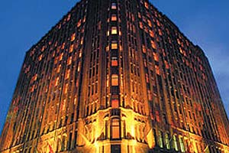
  This first class hotel is situated in the heart of Sydney's central business district.
  (Click for more hotel info)
Tue, 06 Jan 2009 | Mercure Hotel Harbourside, Cairns, Australia  Harbor View Room |  |  | 1 | Twin Room | 3 Nights |  | Included
  Mercure Hotel Harbourside
  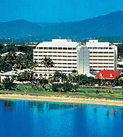
  This first class hotel is located close to the central business district and the casino and convention centre.
  (Click for more hotel info)
Fri, 09 Jan 2009 | Radisson on Flagstaff Gardens, Melbourne, Australia  Standard Room |  |  | 1 | Twin Room | 3 Nights |  | Included
  Radisson on Flagstaff Gardens
  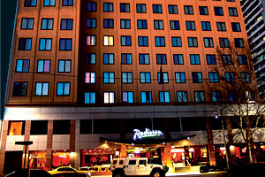
  This first class hotel is situated on the north side of the CBD, overlooking the delightful Flagstaff Garden.
  (Click for more hotel info)
Mon, 12 Jan 2009 | Copthorne Christchurch Central, Christchurch, New Zealand  Premium Room |  |  | 1 | Twin Room | 2 Nights |  | Included
  Copthorne Christchurch Central
  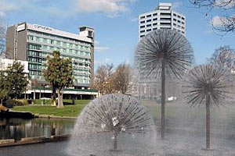
  This first class hotel is located in the heart of the city overlooking Victoria Square.
  (Click for more hotel info)
Wed, 14 Jan 2009 | Scenic Circle Southern Cross Hotel, Dunedin, New Zealand  Superior Room |  |  | 1 | Twin Room | 1 Night |  | Included
  Scenic Circle Southern Cross Hotel
  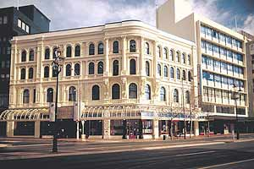
  This first class landmark hotel is located in the heart of Dunedin near to it's many attractions.
  (Click for more hotel info)
Thu, 15 Jan 2009 | Luxmore Hotel, Te Anau, New Zealand  Deluxe Room |  |  | 1 | Twin Room | 1 Night |  | Included
  Luxmore Hotel
  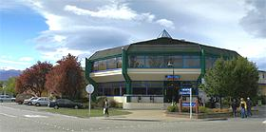
  This superior tourist class hotel is just a short stroll away from the beautiful Lake Te Anau.
  (Click for more hotel info)
Fri, 16 Jan 2009 | Millennium Queenstown, Queenstown, New Zealand  Standard Room |  |  | 1 | Twin Room | 3 Nights |  | Included
  Millennium Queenstown
  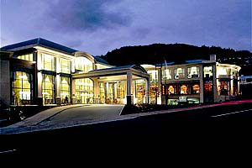
  This deluxe class hotel is located in centre city Queenstown near to it's many attractions.
  (Click for more hotel info)
Mon, 19 Jan 2009 | Heritage Auckland Hotel & Towers, Auckland, New Zealand  Standard Room |  |  | 1 | Twin Room | 2 Nights |  | Included
  Heritage Auckland Hotel & Towers
  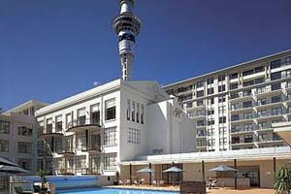
  This first class historic landmark hotel is located in Auckland city center adjacent to Saint Patrick's Square.
  (Click for more hotel info)
Wed, 21 Jan 2009 | Auckland Private Car Transfer - Hotel to Airport |  |  | 1 | Vehicle |  | 95.91 | 95.91
  Auckland Private Car Transfer - Hotel to Airport
  Pickup | Heritage Auckland Hotel & Towers
  Dropoff

Insurance Options
 | Description | Quantity | Price | Total
 | Travel Protection Plan Declined | 2 Passenger | 0.00 | 0.00
 | Travel Protection for Tours from $3000-6000 | 2 Passenger | 139.00 | 278.00
 | Cancel For Any Reason | 2 Passenger | 60.00 | 120.00

This is not an invoice.
Move the mouse over the underlined links for details.
- This invoice includes land only services. Flights originating from or returning to the USA are not included.

